Backwater Horizon
Game Design Document

Matthew Bloom
Version 1.0
Date: 6/20/2019

Table of Contents
High Level Overview 3
Concept Statement 3
Genre 3
Target Audience 3
Player Experience 3
Current Target Platform 3
Art, Sound and Music 3
Player Objectives and Progression 4
Tools 5
Localization 6

Revision History

Version 1.0
xx/xx/xxxx

High Level Overview

Concept Statement
Backwater Horizon is a space opera that takes place in a time where interstellar travel is widespread and the many species of the galaxy survive by any means necessary. The story follows a young mercenary woman and her companions who inadvertently find themselves facing a threat from another galaxy.

Unique Selling Points
TBD

Genre
2D, sci-fi, turn-based tactical, RPG

Target Audience
ESRB rating M (mature): Content is generally suitable for ages 17 and up. May contain intense violence, blood and gore, sexual content and/or strong language.
Those who enjoy turn-based tactical games like:

- Battle Brothers (no rogue-like elements, though)
- Final Fantasy Tactics
- Fire Emblem
- Shining Force
- Tactics Ogre
- XCOM

And those who enjoy a band of protagonists like those found in:

- Firefly
- Guardians of the Galaxy
- Mass Effect
- Star Wars

Player Experience
The player is first introduced to Victoria Grissom, the main protagonist of the story. The player follows Grissom's story as she joins up with a down-and-out mercenary band who is in the process of increasing its numbers and acquiring bigger and better contracts across the galaxy. Grissom meets other mercs from a wide variety of other galactic races whom become companions of Grissom's as the game advances.
Gameplay should be fast-paced for the player with relatively little downtime. When the player has a character fire a weapon, the gun should respond quickly without having to deal with long, drawn-out cutscenes as seen in Shining Force or extensive action animations as seen in Final Fantasy Tactics. As Damion Schubert said in his talk on "Resonance," a player will make their mind up about a thing within 2 seconds. After that, you must overcome the prejudices they developed. Every second should be filled with a certain level of interaction for the player to keep their state of "flow" in constant motion.
From an emotional standpoint, the goal is to have the player develop relationships with these characters to make fights and encounters more impactful. When a character falls in battle, the player should feel sorrow or a certain level of vengeance. When a character expresses their inner thoughts during dialogue, the Player should feel a certain sense of belonging and companionship.

Target Platforms
PC

Art, Sound and Music
TBD

Player Objectives and Progression

The Player
*****Who is the player in the game? You may want to link to a page for player personas that you have created for the game.

Beginning of the Game
*****Synopsis of what the player knows when the game starts, and any following in-game narrative.

Player Goals
*****The player’s primary goals and how they progress to them, including which parts are linear or based on player choices.
*****Short-term and long-term goals the player has as they play, and how these evolve.

Gameplay
*****Moment-by-moment gameplay (with links to UI section).

Game World and Background

Backstory Overview
- Important elements of the world fiction that set the stage for the game, but do not directly affect the gameplay.

World Organization
- MVP levels, locations, zones, chapters – including introductory or tutorial areas.

Game World Physics
- Running, flying, falling, etc., -- anything of note for the design.

Story Progression
- How does the player move through the game in terms of locations, chapters, etc.

Easter Eggs
- Easter Eggs planned, if any.

Detailed World Fiction
- Link to a separate page with full detailed world fiction. This can be important to have as background for designers, but shouldn't get in the way of the rest of the game design.

User Interface

Control Schemes
*****Specifics of all needed control schemes (selection, activation, radial or context menu use, tapping, dragging, etc.), ensuring that these are consistent across the game

Screen Flow Mockups
*****Each screen/menu in full functional detail (wireframe, no art), showing the player’s flow through all aspects of the game.

On-Screen Control Mockups
*****For on-screen controls (with links to individual features and systems).

Help System

Game Options
*****Audio, visual, game save, etc.

Art and Sound Style

Art Influence
Most of the art design follows a style similar to that of Soul Knight and Enter the Gungeon.

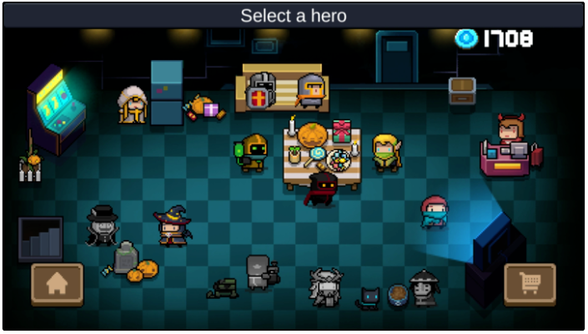Figure 1: Soul Knight player lobby.
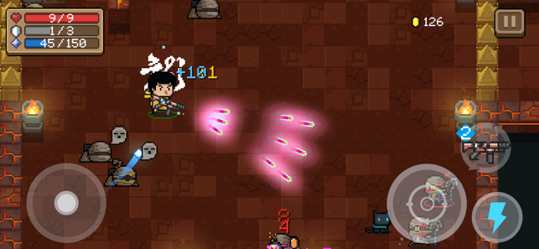Figure 2: Soul Knight character firing a weapon, which pivots around the character’s body.
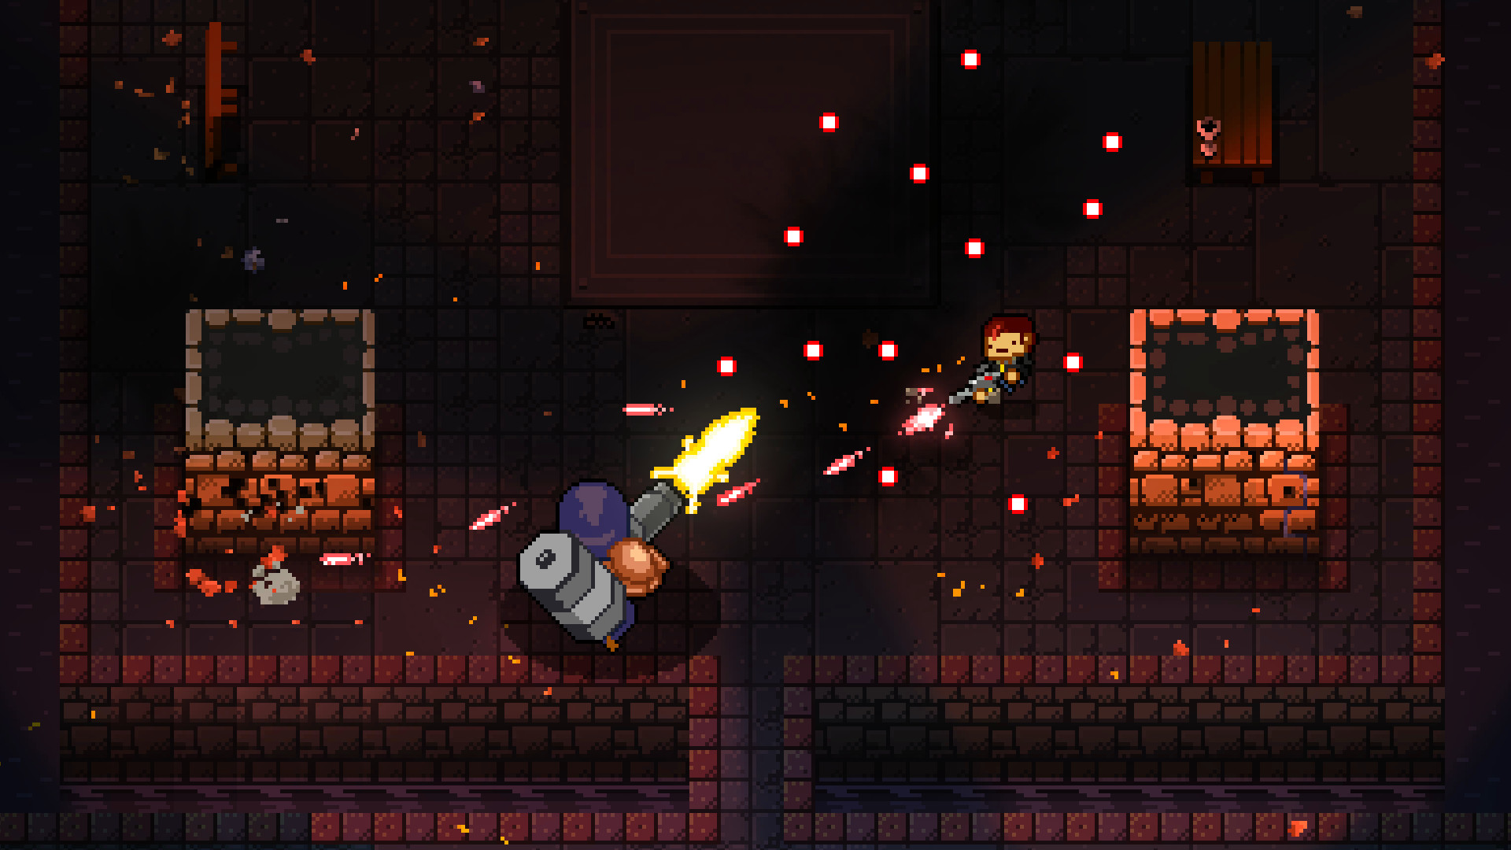Figure 3: Enter the Gungeon character firing a weapon against a boss.
Level design takes influence from games such as Cross Codes overworld, which uses elevated tilemaps to convey depth.

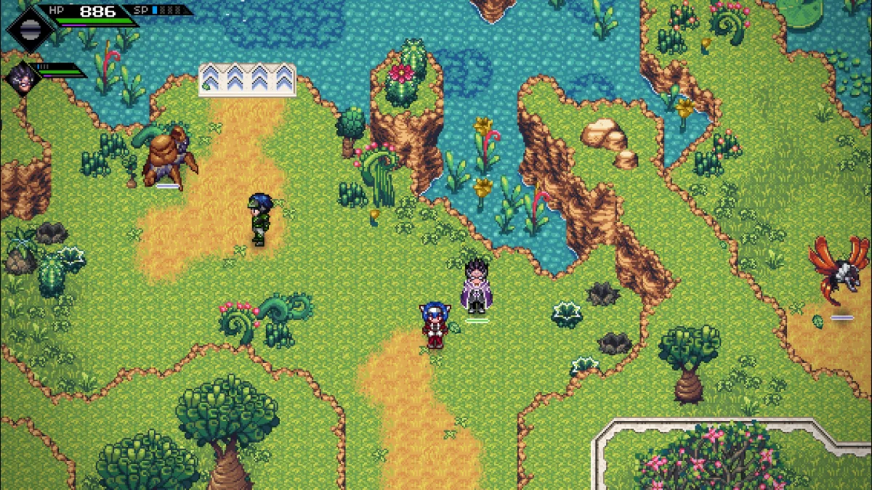Figure 4: Cross Code level design with elevated tilemaps.

Dialogue in the game takes heavy influence from Tactics Ogre. TO also provided the player with the ability to make decisions during cutscenes.

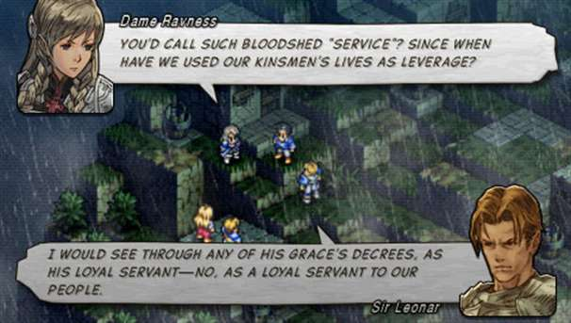Figure 5: Tactics Ogre dialogue exchange between characters.

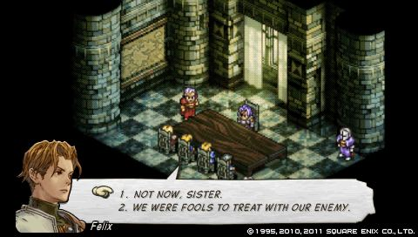Figure 6: Tactics Ogre player choice during cutscene.

Tools

Game Engine
Godot 3.1.2 is used as the game development engine.

Code Repository
Github is used as the primary code repo and is maintained at the following location below:
https://github.com/mbloom88/basic_tactics

A mark-up tutorial can be found here for README.md and CHANGELOG.md files.

Version Control
Version control follows the Semantic Versioning nomenclature (MAJOR.MINOR.PATCH).

- MAJOR version when you make incompatible API changes,
- MINOR version when you add functionality in a backwards compatible manner, and
- PATCH version when you make backwards compatible bug fixes.

Additional labels for pre-release and build metadata are available as extensions to the format listed above.

Development follows a branching model that uses the following branches:

Branch Name | Branches From | Merges Into | Purpose
master | - | - | The main branch where the source code of HEAD always reflects a production-ready state.
develop | master | - | The main branch where the source code of HEAD always reflects a state with the latest delivered development changes for the next release. Some would call this the “integration branch”.  When the source code in the develop branch reaches a stable point and is ready to be released, all of the changes should be merged back into master somehow (Release branch) and then tagged with a release number.
feature | develop | develop | Branch naming convention can be anything except master, develop, release-*, or hotfix-*.  Feature branches (or sometimes called topic branches) are used to develop new features for the upcoming or a distant future release. When starting development of a feature, the target release in which this feature will be incorporated may well be unknown at that point. The essence of a feature branch is that it exists as long as the feature is in development, but will eventually be merged back into develop (to definitely add the new feature to the upcoming release) or discarded (in case of a disappointing experiment).  Feature branches typically exist in developer repos only, not in origin.
release | develop | develop  master | Branch naming convention is release-*.  Release branches support preparation of a new production release. They allow for minor bug fixes and preparing meta-data for a release (version number, build dates, etc.). By doing all of this work on a release branch, the develop branch is cleared to receive features for the next big release.  The key moment to branch off a new release branch from develop is when develop (almost) reflects the desired state of the new release. At least all features that are targeted for the release-to-be-built must be merged in to develop at this point in time. All features targeted at future releases may not—they must wait until after the release branch is branched off.  It is exactly at the start of a release branch that the upcoming release gets assigned a version number—not any earlier. Up until that moment, the develop branch reflected changes for the “next release”, but it is unclear whether that “next release” will eventually become 0.3 or 1.0, until the release branch is started. That decision is made on the start of the release branch and is carried out by the project’s rules on version number bumping.
hotfix | master | develop  master | Branch naming convention is hotfix-*.  Hotfix branches are very much like release branches in that they are also meant to prepare for a new production release, albeit unplanned. They arise from the necessity to act immediately upon an undesired state of a live production version. When a critical bug in a production version must be resolved immediately, a hotfix branch may be branched off from the corresponding tag on the master branch that marks the production version.  The essence is that work of team members (on the develop branch) can continue, while another person is preparing a quick production fix.

Cloning a Branch from the Remote Repo
When starting out, the following commands can be used to clone a specific project branch from the remote repo.

- Fetch all tags and remotes
git fetch --all --tags --prune

- Clone a specific branch
git clone --single-branch --branch <branch> <remote_repo_url>

A specific tag can also be cloned as well from the remote repo.

- Fetch all tags and remotes
git fetch --all --tags --prune

- Clone a specific branch
git clone <remote_repo_url> --branch=<tag_name>

Pull Request for a Working Branch
If a branch has already been cloned locally from the remote repo, a standard pull request can also be made from the working project directory.

- Checkout the branch to be worked on
git checkout <branch>

- Pull request from working project directory
git pull

Creating a New Branch
If a new branch needs to be created for features, releases, and hotfixes, the following commands can be used.

- Checkout the branch that the new branch with branch from
git checkout <branch_from>

- Checkout and create the new branch from the root branch
git checkout -b <branch_name> <branch_from>

Committing and Pushing Branch Updates
Once updates have been made to a particular branch, the changes can be pushed to the remote repo.

- Receive a list of all changes made to the branch
git status

- Add all changes to stage for a potentially commit to the remote repo
Option 1: git add -A (adds all updates)
Option 2: git add <filepath> (adds specific files for commit)

- Commit changes and add comment prior to pushing to the remote repo
git commit -m “update comments”

- Push updates to the remote repo
git push

Merging Branches
If feature/release/hotfix branches need to be merged back to a main branch, the following commands can be used.

- Checkout the branch that will be merged into
git checkout <branch_to_merge_to>

- Merge a target branch back into a main branch
git merge --no-ff <merging_branch>

- Push updated branch to the remote repo
git push origin <branch_to_merge_to>

Tagging a Release
To tag a release on Github, the following commands can be used.

- Checkout the master branch that will be merged into
git checkout master

- Merge the release into the master branch
merge --no-ff release-***

- Tag the new release
tag -a vX.Y.Z -m "tag comments go here"

- Push the tag to the remote repo
git push --follow-tags

A list of tags can also be found by typing the following

- Show git tags
git tag

Deleting Branches
If branches need to be deleted (e.g. after merging) the following commands can be made.

- Delete local branch
git branch -d <branch>

- Delete the branch on the remote repo
git push <remote_repo_url> --delete <branch>

Art Assets
TBD

Music and SFX Assets
TBD

Dialogue System

The game dialogue system reads JSON file content to display dialogue to the player. The format of the JSON files are detailed in the following sections.

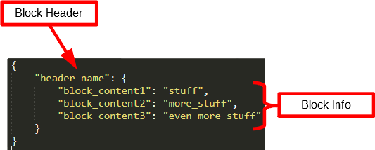Figure 7: JSON file structure for dialogue with example dialogue block.
The JSON format starts with outer dictionary brackets. Each key within the JSON dictionary brackets indicates a header for a block dialogue block. A header key possess an additional dictionary, which represents the dialogue block’s info, which will be addressed in the sections that follow.

Header Nomenclature
The header in each dialogue block is an indicator to the Dialogue system on how to start, stop, and path through the dialogue file.

Header Name | Description
“start” | The first header that the Dialogue system looks for in the loaded JSON file. This “start” header is the very beginning of the dialogue sequence.
“repeat” | After a dialogue has started, the Dialogue system raises a start flag and updates the Event Database accordingly. When the same dialogue is triggered after having started previously, the Dialogue system jumps ahead to the “repeat” header.
“other”

Dialogue Types

Text
The “text” dialogue type is a pre-written dialogue for the specified “speaker,” which is an actor that can be referenced from the Actor Database. This is the most common of the dialogue types used in the game.

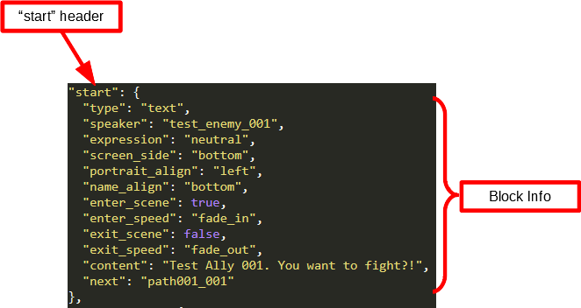
Block Key | Block Values | Value Type | Description
type | text | String | The type of dialogue that the block will initiate.
speaker | <actor reference> | String | The actor that will be speaking. The Actor Database can be referenced for all game actors.
expression | neutral | String | The type of portrait expression to be displayed in the dialogue box.
screen_side | top  bottom | String | The side of the screen that the dialogue box will appear on.
portrait_align | left  right | String | The side of the dialogue box that the actor’s portrait will appear on.
name_align | top  bottom | String | The side of the dialogue box that the actor’s full name will be displayed on.
enter_scene | true  false | Bool | Flag that determines whether the dialogue box is entering the scene.
enter_speed | fade-in  instant-in | String | Determines whether the dialogue box enters the scene slowly or instantly.
exit_scene | true  false | Bool | Flag that determines whether the dialogue box is exiting the scene.
exit_speed | fade-out  instant-out | String | Determines whether the dialogue box exits the scene slowly or instantly.
content | <dialogue text> | String | The dialogue to be typed out in the dialogue box.
next | <next header>  end | String | The next dialogue block to progress to based on the header name.  Listing the next key’s value as “end” will flag the end of the dialogue.

Response
The “response” type follows a similar format to the “text” type, but allows for player choice during dialogue. There are no restrictions to the amount of player response choices.

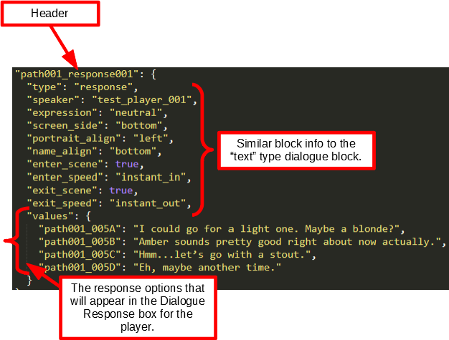
The primary difference between the “response” and “text” dialogue types is the “values” key. The “values” key is a dictionary of header keys and text values. The header keys are header names for dialogue blocks that are the result of the player’s selection of that header key. The text values are the values that are written to the dialogue box on behalf of the player.

Event
Creates a new event in the Event Database. This is a backend operation that does not display in a dialogue box.

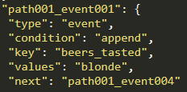
Block Key | Block Values | Value Type | Description
condition | append  boolean  decrement  increment | String | The operation that will occur with the “values” key.
key | <event string> | String | The name of the event. This event key is used to check the event for future dialogues.
values | <string text>  <int value>  <bool value> | Multi | The value to assign to the event key.  Note that the “values” must match the “condition” operation. For example, a “boolean” condition should not have an “int” value assigned.

Divergence
“Divergence” dialogue types are another type of backend operation that checks a dialogue or event from the Event Database against a “condition.” The dialogue will fork between two different dialogue paths depending on if the condition is true or false.

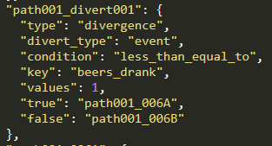

Block Key | Block Values | Value Type | Description
divert_type | dialogue  event | String | The type of divergence event.
key | <name of dialogue or event> | String | The key name for the dialogue or event stored within the Event Database.
values | <string text>  <int value>  <bool value> | Multi | The value assigned to the dialogue or event key that needs to be checked against the “condition.”  Note that the “values” must match the “condition” operation. For example, a “boolean” condition should not have an “int” value assigned.
true | <header name> | String | The next dialogue block to be executed if the divergence condition is true.
false | <header name> | String | The next dialogue block to be executed if the divergence condition is false.

The condition options are dependent on whether the divert_type is dialogue or event.

The dialogue divert_types tend to be more simplistic. The Event Database is checked to see if the dialogue has already been experienced. The path will split between the true/false dialogue paths depending on the boolean result. No condition is needed in this case.

The Event divert_type is more specific than the dialogue divert_type, which checks the key-value pair from the Event Database against the condition. The conditions for the event divert_type are listed below.

Condition | Description
equals | Checks the value in the Event Database and determines if the value matches the condition’s value.
equal_arrays | Checks an array in the Event Database and determines if the array’s content matches the condition’s array.
greater_than | Checks the value in the Event Database and determines if the value is greater than the condition’s value.
greater_than_equal_to | Checks the value in the Event Database and determines if the value is greater than or equal to the condition’s value.
less_than_equal_to | Checks the value in the Event Database and determines if the value is less than or equal to the condition’s value.

Random
This backend operation random selects the next dialogue block base on the header choices in the “values” array.

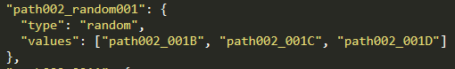

To-Do

- Add cover mechanic.
- Add a visual turn-queue to the screen.

Appendix

Appendix A: Acronyms

Acronym | Description
GDD | Game Design Document
MVP | Minimum Viable Product
RPG | Role-Playing Game

Appendix B: Guides and References

A* Pathfinding
Name | Link | Description
Astar – Godot Documentation | https://docs.godotengine.org/en/3.1/classes/class_astar.html | Explanation of Godot’s A* node.
Easy A* (star) Pathfinding | https://medium.com/@nicholas.w.swift/easy-a-star-pathfinding-7e6689c7f7b2 | Intro and Python-based implementation for A*.
Introduction to the A* Algorithm from Red Blob Games | https://www.redblobgames.com/pathfinding/a-star/introduction.html | Fantastic visual tutorial on A*.
Pairing function | https://en.wikipedia.org/wiki/Pairing_function | A pairing function is a process to uniquely encode two natural numbers into a single natural number. Used to generate unique IDs using X and Y Vector2 coordinates for the Godot A* node’s pathing algorithm.
Taxicab geometry | https://en.wikipedia.org/wiki/Taxicab_geometry | Manhattan distance calculation can be used to determine move “costs” for right-angle movements when running the A* pathing algorithm in Godot.

Godot and GDScript
Name | Link | Description
GDQuest Documents | https://www.gdquest.com/docs/ | Godot coding guidelines from the group at GDQuest.
Kids Can Code (KCC) Godot Tutorials | http://kidscancode.org/blog/tags/godot/ | A number of blog and video tutorials for a variety of Godot features.

Graphing Tools
Name | Link | Description
Desmos | https://www.desmos.com/ | A variety of math and graphing tools.

Appendix C: Media Influences and Game References

Empires, Mercenary Groups, and Races from History
- American western frontier life
- Mongol Hordes
- Norse/Vikings and their mythology
- Three Kingdoms Era of China
- Varangian Guard

Games
- Anarchy Online
  - Multiple class systems that are pretty unique (engineer, metaphysicist, etc).
  - Implant mechanic

- Cross Code https://www.youtube.com/watch?v=V-8y8HgR-Fs
  - Top-down 2D (orthographic) art style
  - Variable terrain heights that the player can scale

- Mass Effect Trilogy
  - Branching dialogue and story
  - Unique squad members with their own side stories
  - The Normandy (space ship) as an HQ for the team.

- Ogre Tactics https://www.youtube.com/watch?v=Hu_ybOeXnMI
  - Dialogue bubble system with player choices during conversation.
  - Bust portraits for each character.
  - Character art style
  - Cutscene mechanics

- Shining Force I/II https://www.youtube.com/watch?v=pewTGCkt4qE
  - 2D top-down (orthographic) overworld navigation style
  - Camera system for shifting between players and events (battles, overworld, etc)
  - Turn-order is based on a character’s movement speed rather than whole teams moving at once

- XCOM: Enemy Unknown https://www.youtube.com/watch?v=-0KNOGNxDVY
  - Cover mechanic
  - Overwatch mechanic
  - Fog of war mechanic
    - One of the sniper’s perks gives the whole team its sight distance. An interesting tactic that can be used in battle.
  - Reload mechanic (but need to include ammo numbers)
    - The drawback to the XCOM system is that the reload indicator is a weapon shape that is solid color when full and see-through when empty. This makes it hard for the player to determine if a move will completely drain a clip.
  - Simple stat and loadout systems that make battles more strategic (prevent stat bloat like standard JRPGs).

Media
- Alien movie
  - The idea that there is something out there that just lives to consume and destroy.

- Blues Music
  - Deep south, swamp blues

- Saga
  - Comic-style art (heavy black lines...especially the cover), text bubbles, and action FX

- Space Western Genre
  - Firefly gave a pretty good sense of western meets space opera.

- Star Wars
  - Mandalorians (both their warlike nature and tendency towards bounty hunting)

